1 the substance / mixture and of the company DEFINITION
1.1.The substance/mixture ID
Product form: Mixture
Item name: TERMINATOR PLUS CARPET SHAMPOO
1.2.The designated uses of the substance or mixture and non-recommended use
1.2.1.Identified uses
Carpet shampoo
1.2.2.Non-recommended use
There is complementary information
1.3.The information of the supplier of the safety data sheet
PRODUCT NAME | TERMINATOR PLUS CARPET SHAMPOO
PRODUCT CODE | QW
USE | CARPET SHAMPOO
MANUFACTURER | QUICK WAX (CHEMISTRY, MANUFACTURING, FOREIGN TRADE LTD. LTD)
ADDRESS | Yaylacık Mah.37.Sk.No:11 NILÜFER/Bursa/Turkey
PHONE | 0224 3 88 2518/251 3 999
e-mail | www.quickwax.com.tr
emergency telephone number: | 112 ( emergency medical services)  114 (uze I )

2. DEFINITION ZARALILIK
2.1. Article classification of the mixture
Numbered 28848 dated 11 December 2013 (Repeated) published in the Official Gazette “classification of substances and mixtures, Yonetmelike About labelling and packaging (SEA) in accordance with the classification

Skin sensitizer :H317
Acute aquatic toxicity :H412
Tah Skin.2 :H315
Eye-Tah.1 :H318
2.2. Label elements
The sign of harmfulness (SEA):
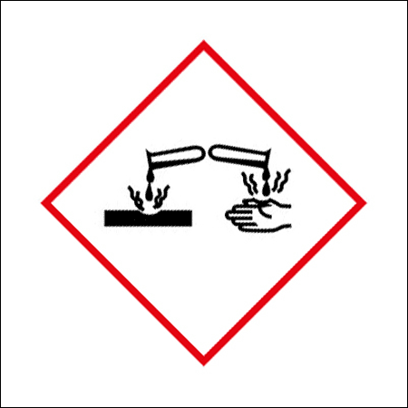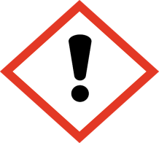
Word of warning (SEA): Danger Caution
Ifa harmfulnessbreak (sea): H317:may lead to allergic skin reactions
H412:harmful to aquatic environment, long-lasting, detrimental effects
H315:causes irritation to skin
H318:causes serious eye damage
Precautionary statements(SEA): P501:dispose of Contents container
P280: protective gloves/protective clothing/goz protective/face protection use
P321:Specific intervention is necessary(see the label)
P273:avoid being given to the environment
P261:Dust/fumes/gas/mist/vapors/spray avoid breathing
P272:contaminated clothing out of the workplace C AIto adopt
P363:wash contaminated clothing before
If on skin P302+P352:in case of contact with skin: wash with soap and water
P333+P313:skin irritation question: medical assistance/intervention buy
P233:keep container tightly closed
P264:after handling.... Wash with
P332+P313:if it comes to skin irritation:seek medical attention
P362:remove contaminated clothing and wash before using
If in eyes P305+P351+P358:in case of contact with eyes:rinse cautiously with water for several minutes. Plugged in and is easy to do, remove contact lenses, if. Continue rinsing
P310:Immediately No. 114 of the National Poison Control Center PHONE doctor or doctor / physician P302 if on skin call+P353:in case of contact with skin:wash with soap and water
2.3. Other damages
Classified hazards which cannot be
There is complementary information
3.INFORMATION ABOUT THE COMPOSITION OF THE INSIDE
3.1.Ingredients
Name: Terminator Plus Carpet Shampoo
Item | C% | CAS no | EC No | Harmfulness class and category code code | Code Harmfulness Statement
methyl Dodecyl amine oxide |  | 1643-20-5 | 216-700-6 | Acute Tok.4  Tah Skin.2  Eye-Tah.1  Akut1  Acute Aquatic.2 | H302  H315  H318  H400  H410
Essences |  |  |  | Aquatic Acute Tok.2  Tah Skin.2  Eye-Tah.2  Hass Skin. | H335  H315  H319  H317

All (H) for the full text of Clauses 16. The Section Are Given.
3.2.Mixture:
Does not apply

4.FIRST AID MEASURES
4.1. Explanation of first aid measures
Inhalation:
Go to the nearest hospital and the victim should be moved to a fresh air environment.
Swallowing:
Should not force to vomit, and plenty of water should be given. Medical advice should not be given anything by mouth if loss of consciousness occurs, and never should be taken.
Contact With Skin :
Case of contact, wash the area with plenty of water for at least 15 minutes must. The transmitted clothes, shoes, remove immediately and wash thoroughly before reuse and medical advice should be taken.
Contact With Eyes:
Wash with plenty of water for at least 15 minutes with eyelids held open, and medical advice should be taken.
4.2. Important symptoms and effects, acute and post
Symptoms of skin contact: skin irritant
After eye contact symptoms/effects: eye irritant
4.3. The need for medical attention and special treatment marks the first
Treat symptomatically
5.FIRE-FIGHTING MEASURES
5.1.Fire extinguishers
Suitable Extinguishing Media :
In adaption to materials stored in the immediate neighbourhood, the extinguishing process can be performed.
5.2.Substance or profitsspecial damages arising imdan
Special Risks :
There is complementary information
5.3.Specific recommendations for fire suppression crews
Special Protective Equipment For Fire Fighting:
Breathing apparatus in hazardous areas without stand. A safe distance to avoid contact with skin should be considered and appropriate protective clothing should be worn.
Other Information :
Contain escaping vapors with water. Leakage into groundwater or surface water fire extinguishing water must be prevented.
6.ACCIDENTAL RELEASE MEASURES
6.1.Personal precautions, protective equipment and emergency procedures
6.1.1. For non-emergency personnel :ventilate spill area. Source of open flame, Sparks and smoking is prohibited. Dust/fumes/gas/mist/vapour/spray. Avoid contact with skin and eyes.
6.1.2.For people who intervene in case of emergency: do not attempt to intervene without suitable protective equipment. For more information, see bolum8: “ exposure controls/personal protection”.
6.2.Environmental precautions :
Should not be allowed to enter the sewage system.
6.3.Methods and materials for containment and cleaning up
Cleaning process:
Absorbent and neutralising should be impregnated with the substance. Product should be collected in a container. Neutralization without drainage should not be done.
6.4.References to other sections
For more information, see Chapter 13.
7.HANDLING AND STORAGE
7.1.Precautions for safe handling
Usage precautions :
Should be studied to shed the skin with plenty of water in case of contact with personal cleansing should be done. Wash hands before leaving the work place and contaminated places. Mechanical ventilation or local exhaust ventilation may be necessary.
Storage precautions :
Tightly closed original container in a dry, should be stored in a cool place. Away from food, drink and animal feed should be kept away from. Away from heat, sparks and flame must be protected.
7.2.Conditions for safe storage, including disputes
Technical measures:snap connect the ground container and receiving equipment
Storage conditions:store in a well-ventilated place. Keep container tightly closed. Store under lock and key
7.3. Specific end use (S)
There is complementary information

8.EXPOSURE CONTROLS/ PERSONAL PROTECTION
8.1.Control parameters
There is complementary information
8.2.Exposure controls
Personal Protection :
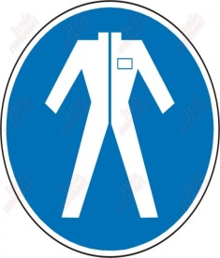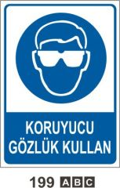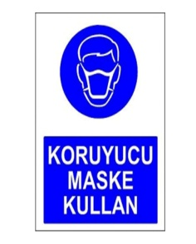
Technical Measures :
Exposure controls are adequate in order to confirm that the substances in the breathing zone of workers or in the general workplace may require monitoring of concentrations in the air.
Respiratory Protection :
There was a specific recommendation,but due to the overall level exceed the recommended occupational exposure limits respiratory protection when it is essential to use.
Hand Protection :
Protective gloves should be used.
Eye Protection :
Approved safety goggles should be worn.
Other Prevention Methods :
Appropriate clothing to prevent repeated or prolonged contact with liquids or steam all possibility dressed.
Health Measures :
***DON'T SMOKE IN THE WORK PLACE ! *** Change every shift and before eating,smoking and using the toilet wash hands before before.Shouldn't eat anything during use,do not drink and shouldn't smoke.
Skin Protection :
Necessarily aprons and protective clothing to prevent skin contact should be worn.
9.PHYSICAL AND CHEMICAL PROPERTIES

APPEARANCE | Liquid
ODOR | characteristic
the color | Orange
relative density | not available
Flash Point | not available
boiling point | not available
danger of EXPLOSION | is not present,
the resolution is | Excellent
vapour pressure | not available
pH value | PH 8-9

9.2.Other information
There is complementary information

10.STABILITY AND REACTIVITY
10.1.Reactivity
The product is in normal use, storage and transport are not under reactive conditions.
10.2.Chemical stability
Stable under normal temperature conditions and recommended use conditions.
10.3.Possibility of hazardous reactions
Hazardous reactions none known under normal use conditions
10.4.To Be Avoided
Avoid contact with hot surfaces. The job. Avoid flames and sparks. Eliminate sources of ignition
10.5.Incompatible materials
There is complementary information
10.6.Hazardous decomposition products.
Dangerous decomposition products are not expected under normal storage and use conditions
11.TOXICOLOGICAL INFORMATION
11.1. Information about the toxic effects
This product has not been tested as a whole.
Inhalation :
High-intensity prolonged inhalation of the substance of the case, can harm the respiratory system.
Ingestion :
Liquid irritates mucous membranes and may cause abdominal pain if swallowed.
Contact With Eyes :
May irritate eyes.
Contact With Skin :
Skinsensitivity can be seen te. If exposed to prolonged contact may cause skin irritation and asthma.
Health Alerts :
Steam can affect the central nervous system, headaches, and vomiting may cause discomfort.
Other Health Effects
There is strong evidence that the carcinogenic qualities of this substance.
12.ECOLOGICAL INFORMATION
12.1.Toxicity

Acute aquatic toxicity:in the aquatic environment, long-lasting, detrimental effects may have
Chronic aquatic toxicity: not classified

12.2.Bioaccumulative Potential :
There is complementary information
12.3.Persistence and degradability :
No known significant effects or critical hazards.
12.4.Mobility in soil:
There is complementary information
12.5.Results of PBT and vpvb assessment:
There is complementary information
12.6.Other adverse effects:
There is complementary information

13.DISPOSAL INFORMATION
13.1.Waste treatment methods:
General Information :
When dealing with a lot of waste, engage the safety measures to be taken in the product itself should be taken into consideration. Packaging should be empty.
Methods Of Disposal :
Garbage and waste should be disposed of in accordance with the rules of the local authorities. Responsible for all large debris should be informed about the environment. Sewers ,water courses or the soil should be allowed to enter. Atmadan containers must be empty before.

14.TRANSPORTATION
UN number | not classified
CLASS TRANSPORT HARMFULNESS | Unrated
AMBAJLAMA in the group | were not classified
environmental damages that | the user always transport in closed containers that are upright and secure in the spaces that belong to. Persons transporting the product know what he should do give information about an accident or spillage.
MARP73/78 AND THE IBC CODE NO BE ACCORDING TO THE TOTALTRANSPORT | NO DATA AVAILABLE
14.6.Special precautions for user:
There is complementary information
15.REGULATORY INFORMATION
15.1. Specific for the substance or mixture safety, health and environmental legislation
Safety Data Sheet for hazardous substances and mixtures regulation ( 13/12/2014-29204 numbered Official Gazette )
16.OTHER INFORMATION

Full text of H statements:
Harmfulness Statements :
H319:causes serious eye irritation.
H302:harmful if swallowed
H315:causes skin irritation
H317:may lead to allergic skin reactions
H400:very toxic in the aquatic environment
H410:in the aquatic environment, long-lasting, toxic effect
H412:harmful to aquatic environment, long-lasting, detrimental effects
Sources of information : raw materials, obtained from manufacturers Safety Data Sheet has been prepared based on.
Updated Date :
In the first 1. Version.
Author :
Name and surname : GULSUM SAKIN
Signature :
Document no : TUV/01.214.02

Security information form tothe flourin the data based on our present knowledge and is intended to define the safety requirements for the product. Given this information, given any guarantee for any special or general application in the form of the specification, or cannot be understood. Drank a lot less dangerous product according to the product disclosure, even though it is the form recommended by the manufacturer measures to be taken. The appropriateness of the method used and the intended use of any responsibility for the product remains with the user. Any damages that may occur from the use of Information Form, our company will not be held responsible. In each case our general sales conditions apply.

